**Ye Olde Balloon Bible**

A Student’s Guide to balloon launching, written by students for students, passed down from generation to generation. Please update after every launch with a synopsis of what flew and how things went. There is no such thing as too much information, please make this a true “bible” to answer all ballooning questions.



Bryan Hetzer

NearSpace Balloon Payload Program

Updated as of: 06/16/15

Contents

Traditional Tracking Systems D700 4

Materials (for using TM-D700) Radio 4

Tracking Antenna 4

GPS 5

“Ethernet-like” cable 5

Power/Gnd 5

Panel 4

Assembly 6

Operation 6

General Operation 6

GPS operation 7

Alternate Tracking System 8

Materials 8

Assembly 9

Operation 9

General 9

Alternate GPS operation 9

D710 Tracking System 10

Materials (for using D710) 10

Radio 10

**Panel** 11

**Other Materials** 11

**Assembly** 11

**Operation** 12

**General Troubleshooting** 12

Useable Callsigns as of 05/27/15: 13

Command Module 13

Command Module Equipment 13

Traditional Setup 13

New Setup 16

Pre-Launch Checklist 18

Logistics 18

Flight Director Checklist 19

Weather Predictions and Predicted Landing Sites 25

Prepping the Payloads for departure 25

General 25

Tracking Tests 26

Active Tracking Instructions for chasing your payloads 27

The Tracking team 27

Approaching the landing site 29

General 29

Approaching the house and getting permission 29

Retrieving the payloads 30

Launch Accounts 32

NS-44 Log (Fall 2014) 32

Bryan Hetzer’s account: 32

NS -47 (Spring 2015, Launch 2) 34

Bryan Hetzer’s Account 34

NS-48 (Summer 2015, Launch 1) 35

Bryan Hetzer’s account 35

Ongoing Research 37

Laptop APRS plotting/tracking Materials 37

*Radio* 37

Assembly 39

Operation 40

Testing results 40

# Traditional Tracking Systems D700

## Materials (for using TM-D700) Radio

Quick tip: If you’re looking for anything in here and can’t find it quickly… ctrl+F is great!

TM-D700 Protocol Data Communicator (Kenwood) [Item 1]  
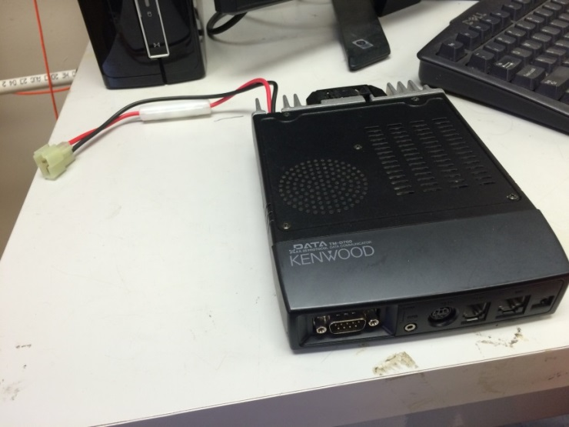

|  |  |
| --- | --- |
| Tracking Antenna  (Labeled : Tracking) [Item 2]    **We have 2 tracking antenna at the lab, both can be used on any tracking setup**  GPS  GPSmap 276C (Garmin) [Item 4]  “Ethernet-like” cable  Used to connect panel to radio [Item 5]  Power/Gnd Cluster of wires, with car socket attached. Includes power cables for radio and GPS, as well as a “headphone jack” looking plug [Item 6] | Panel FM Dual Bander TM-D700 (Kenwood, Label : Tracking Vehicle TM-D700 Display) [Item 3]  On the right side – 2 double knobs – base knob controls squelch, higher knob controls volume |

## Assembly

* Plug antenna [Item 2] into back of the radio [Item 1], and screw it in to secure it
* Take the car plug from [Item 6], and plug them into the car outlet
* Attach the red and black cables from [Item 6] to the red and black cables from the radio [Item 1]
* Plug in “headphone cord” from [Item 6] to [Item 1] (port labeled “GPS”)
* Connect the display [Item 2] to the radio[Item1] using “Ethernet cord” [Item 5]
* The remaining chord from [Item 6] will hook up to the back of the GPS [Item 4].

## Operation

### General Operation

* If you’re lucky, the settings should be all set up already
* Open menu
* Go to APRS
* Press OK
* Make sure you’re in menu 3-3, should read APRS WAYPOINT,
* Make sure that it is set to 6 DIGITS NMEA.   
  This will ensure that the GPS NMEA string received by the system will be sent out to the GPS display panel, and it will automatically plot the incoming data packets. It will automatically plot your data packets and you get real time position! ☺
* **Ensure the Panel is listening on the frequency 144.39**. We USED to fly radios that also transmitted on the frequency 144.34, and we would have to scan in between channels to listen for the different packets. This is not currently the case, and you can leave the setting on 144.39.
* If you have any other specific questions, YouTube can be really good for figuring this stuff out!
* Here is a helpful link to make sure your station has its TNC open and is broadcasting…  
  https://www.youtube.com/watch?v=ePczHhORUQ4
  + Recap
    - Make sure the frequency on the left hand side is selected, and is tuned to 144.390
    - Hold the F key until the panel beeps.
    - In the bottom left corner, there is an option named TNC. Select it. This will open the Terminal Node Controller (TNC) and allow you to decode incoming data packets.
    - If you wish to beacon your position, go to the same menu in which you found the TNC option. On the bottom row, there is an button for BCON. Select it and you should be broadcasting your position via APRS for the other stations to track you.
* In order for everyone to keep track of each other, it is helpful to use your tracking ground station in order to beacon your position.
  + Hold the F key until the panel beeps
  + On the bottom row, there is a button for BCON. Select it.
  + This will toggle your BCON. If you see “BCON” on the top row of the main display screen, your position is beaconing, and your position will be transmitted with your callsign.
  + To change the interval at which you transmit
    - Go into the menu (MNU)
    - Select APRS 3-D
    - Scroll through and select the interval at which you wish to transmit.
  + Make sure that the PACKET TX option is set to AUTO
    - Go into the APRS-C option to find this setting

### GPS operation

* The GPS should power on by itself when power is applied to the assembled system (If not, hold the power button)
* Press enter to get past the opening screen
* Press “quit” to bring up the map display. This will show the last known location of the GPS, and will show plotted APRS packets as waypoints.
* On this display, APRS callsign packets will be plotted as waypoints. Use the “In” and “Out” buttons, as well as the larger pad to scroll across the map to find the waypoints you are looking for.
* If the map is too cluttered, you can clear all the old waypoints. To do this, go to the main menu (Press “Menu” twice”). Highlight “Points” and press “Menu”. Select the “Delete All” option, and all the waypoints will be removed from the map.
* If you cannot locate a callsign, you can go to the waypoint in the waypoint menu and go directly to the callsign. To do this, open the Waypoint list (from the map, press “Menu” two times highlight “points”). This will bring up a list of recent waypoints, and their associated callsigns. For example, if you wanted to locate W3EAX-9, find W3EAX-9 on the waypoint list. Highlight it, and press the “Enter” button, then select the “Show Map” option. This will place your cursor over the selected waypoint. This can be a good way to find another transmitting vehicle or any lost payloads!
* The GPS will plot any received APRS packets on the map automatically. If it does not, something may have been changed in its setup. Some of the settings it has as of 5/26/15 (still functioning at this time) are as follows:
  + Under “Setup” in the main menu
    - The “COM1” tab says the *Serial Data* *Format* is “NMEA In/NMEA Out”, and the *Baud Rate* is 4800
    - The “Location” tab says the *Location Format* is hddd°.mm.mmm’, the *Map Datum* is “WGS 84”, “Heading” is “Auto Mag Var”, and Magnetic Variation is 11 $°$ west.

That was the setup for the “end-all-be-all” tracking system. This system has served us well for many years, though there will probably come a day where things simply stop functioning. We’re still continuing to use APRS as a means of tracking, but this is definitely NOT the only way to track your payloads. Though it is the most reliable method to date…

# Alternate Tracking System

This tracking system works identical to the traditional tracking, except the GPS display is a little more primitive and it requires a slightly different setup.

## Materials

* 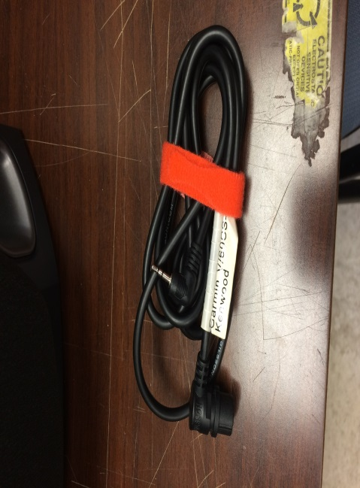[Item 1] [Item 2] [Item 3] and [Item 5] from the traditional setup
* Alternate GPS cord [Item 7]
* Alternate GPS [Item 8]  
  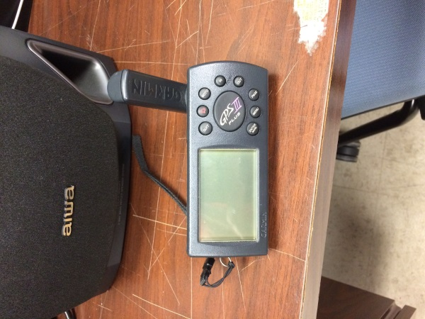
* 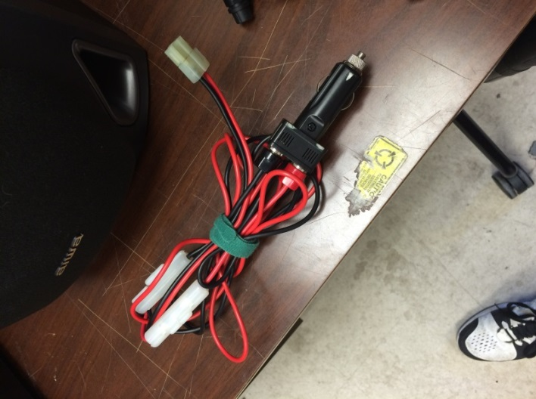Alternate power cord [Item 9]

## Assembly

* Plug antenna [Item 2] into back of the radio [Item 1], and screw it in to secure it
* Take the car plug from the alternate power cord [Item 9], and plug it into the car outlet
* Attach the red and black cables from [Item 6] to the red and black cables from the radio [Item 1]
* Take the alternate GPS cord [Item 7] and plug the “headphone jack” part into the radio [Item 1] on the port labeled “GPS”
* Take the other end of the alternate GPS cord [Item 7] and insert it into the alternate GPS [Item 8]
* Connect the display [Item 2] to the radio[Item1] using “Ethernet cord” [Item 5]

## Operation

### General

* This should work identical to the traditional tracking, except that the alternate GPS is not colored and does not have a backlight. It should plot the incoming packet automatically, though the alternate GPS is a little slower and every time it updates the screen will blank for a second. Don’t panic, this is totally normal! It will reappear with the updated positions in just a split second.

### Alternate GPS operation

* To turn on the GPS, hold the red button with a light bulb on it.
* Once powered on, press continue (“Enter”) then press the “Quit” button 4 times. This will take you to the map screen, where you will see the last known GPS coordinates.
* On this display, APRS callsign packets will be plotted as waypoints. Use the “In” and “Out” buttons, as well as the larger pad to scroll across the map to find the waypoints you are looking for.
* If the map is too cluttered, you can clear all the old waypoints. To do this, go to the main menu (Press “Menu” twice”). Highlight “Waypoints” and press enter. This will bring you to a list of all existing waypoints plotted on the map. Press “Menu” again, and highlight the “delete all” option and press enter. This will delete all existing waypoints on the map.
* If you cannot locate a callsign, you can go to the waypoint in the waypoint menu and go directly to the callsign. To do this, open the Waypoint list (from the map, press “Menu” two times and press enter while “waypoints” is selected). Scroll down the list and find the callsign which you wish to locate. For example, if you wanted to locate W3EAX-9, find W3EAX-9 on the waypoint list. Highlight it, and press the “GOTO” button, then press “Enter”. This will place your cursor over the selected waypoint. This can be a good way to find another transmitting vehicle or any lost payloads!
* The GPS will plot any received APRS packets on the map automatically. If it does not, something may have been changed in its setup. Some of the settings it has as of 5/26/15 (still functioning at this time) are as follows:
  + Under “Setup” in the main menu
    - The “Interface” tab says the *Format* is NMEA, and the *Baud Rate* is 4800
    - The “Position” tab says the *Position Format* is “hhdd.ddddd°”, and the *Map Datum* is “WGS 84”
    - The “Simulator” tab says *Mode* is Simulator off, *Track Control* says “Auto track”

***Note:*** Each car on the chase should be equipped with a radio which broadcasts a different callsign. This will allow all tracking vehicles to know where the rest of the team is during the chase.

# D710 Tracking System

***Note: The D710 Tracking System cannot be used with traditional GPS setup. It can only be used with the Alternate GPS setup***

## Materials (for using D710)

### Radio

Radio for the D710 [Item 10]

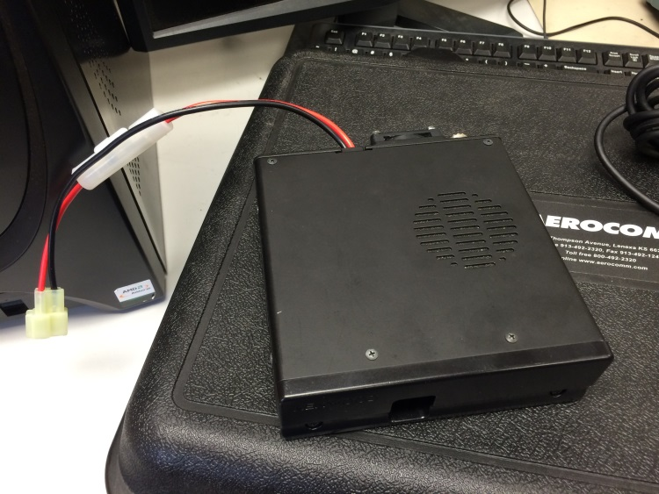

**Panel**

Panel for the D710 [Item 11]

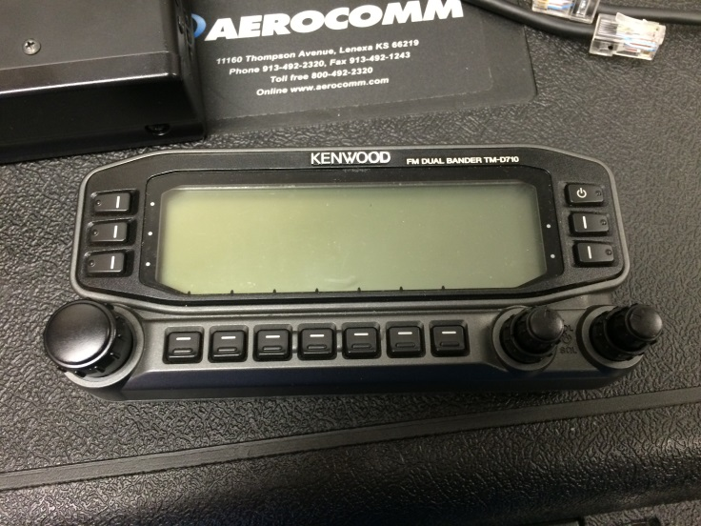

**Ethernet Cable**

Notice how both ends of this Ethernet are identical, unlike the D700 setup. These are two different cords. [Item 12]

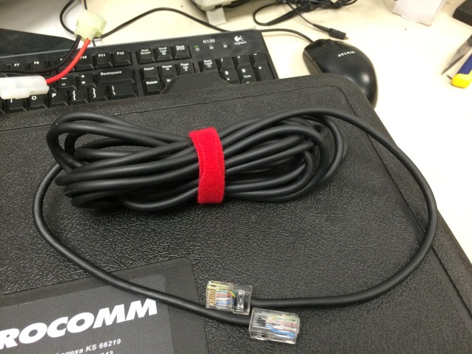

**Other Materials**

(The Tracking Antenna [Item 2], and alternate GPS setup [Items 7, 8, and 9] are used with the D710 setup. ***D710 cannot be used with the traditional GPS Setup***)

**Assembly**

* Connect the alternate power cord [Item 9] to the D710 radio [Item 10].
* Connect the Ethernet [Item 12] into the “panel” slot of the radio, and into the D710 panel [Item 11].
* Plug in the antenna [Item 2] to the back of the radio [Item 10].
* Attach the alternate GPS cord [Item 7] into the alternate GPS [Item 8]
* Attach the “headphone like” end of the alternate GPS cord [Item 7] into the D710 panel [Item 11].

**Operation**

Bryan’s Account (6/9/15):

As of yet, I cannot get this station to decode packets correctly. I have assembled it in the manner I outlined in the “Assembly” section, but it doesn’t seem to be working. After looking online for a long time, I learned a few things about the panel and how to navigate it, though I cannot find a fix for our problem. The problem exactly is that even though the packets can be heard (a small transmission beep can be heard through the squelch static), the packets are not being received and decoded. I tried using the manual to get some clarification on this matter, but I was not able to find any useful information. (<http://www.kenwoodusa.com/UserFiles/File/UnitedStates/Communications/AMA/Manuals/RC-D710_CD-ROM_English.pdf>)

The manual and all other online sources all seemed to say the same thing: receiving and decoding packets should be easy with the following procedure; Ensure that the panel is tuned to the correct frequency (144.390) and that the APRS TNC is open (by pressing the TNC button in the bottom right corner until APRS12 appears above the frequency display).

This was all the more insight I was able to find, and as such I looked at the more in-depth APRS settings in order to see if perhaps something was changed. The search yielded no results, and as such I did a full factory reset on the panel. After this, I figured that any strange anomalies in the system would go away and the panel would work like normal now.

The system still does not read incoming packets, and I’m not sure what to do at this point. A few thoughts come to mind…

* Setup troubles – maybe the assembly is faulted? I can’t think of what could possibly be wrong, though it’s always a possibility
* Fried radio – the D710 radio [Item 10] could be faulty. Something internally that just won’t work anymore? It also unlikely, but maybe. It’s doubtful that the antennas don’t agree with the system and I know for a fact that the alternate GPS system still works.
* If anyone else wishes to try and figure out how to use the D710, go for it! At this moment in time, since we do not have enough antennas to get all the stations working at the same time anyway (we have 2 D700 systems, 2 GPS systems, and 2 antennas, therefore we don’t need the third right now). So as of right, now (6/9/15) the D710 is not mission critical, though it could be nice to know how to use it

**General Troubleshooting**

* Before you mess with any new settings, make sure everything is plugged in correctly!

# Useable Callsigns as of 05/27/15:

**W3EAX – University of Maryland Radio** club (make sure you contact the radio club and tell them that we are using the callsign for a given launch)

**KB3ZZI – Bryan Hetzer** (UMD Alumni - “You can use my callsign anytime; it should be good until 2/19/2023. Also give me a call/email if you have any trouble with the tracking or anything else and I’ll do my best to help!” – Bryan)

**KC3EMR – William Cooper Gilbert** (UMD Senior)

**KD2IFB – Nick Rossomando** (UMD Senior)

**KC3EMV – Camden Miller** (UMD Junior)

**KC3EMQ – Sky Onimus** (UMD Sophomore)

**KC3EMU – Peter Wright** (UMD Sophomore)

**KD2DRI – Steve Lentine** (NASA Goddard)

# Command Module

## Command Module Equipment

### Traditional Setup

* + - Command Module Shell – The container in which all the command module components are housed, this container fits into the orange pouch which is attached directly beneath the hula-hoop of the main payload structure

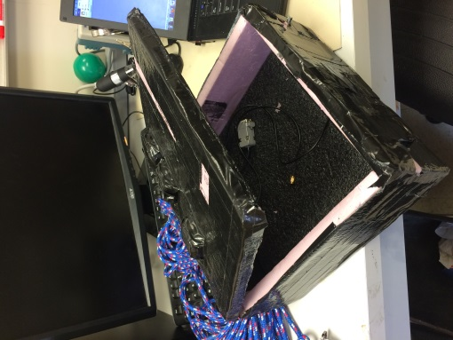

* + - Tiny Trak Transmitter
      * Powered by 8 AA batteries and connected to a round Garmin GPS, this is the tested and true method of tracking. This module cannot be reprogrammed, as the input plug for it was accidentally thrown out some time ago. Even if we had it, none of our computers could connect to it because no modern computers have that kind of interface anymore. In any case, it permanently broadcasts the University’s Callsign, W3EAX-9, and will always be ready to go as long as you have the round Garmin GPS and 8 AA batteries.
      * Since the module is old and cannot be replaced, treat it gently. When powered on, the tracker’s LED will blink green until it has found a GPS lock. Once it has a GPS lock, it will change from blinking green to solid green. The transmitters LED will flash orange whenever it is sending a packet.
      * The round Garmin GPS is currently strapped to the command module shell (as of 5/28/15), and is functional. The Tiny Trak can be plugged straight into the GPS.
      * APRS acts both in a line-of-sight manner. This means that you can see a packet transmitted by the module if have line of sight with it. APRS is also rebroadcasted through digipeater towers. If the module has line of sight with a digipeater, the digipeater will re-broadcast the signal stronger, and, most of the time, that is what you will be seeing while you are chasing the payloads.
      * Equipment Includes
        1. 8 AA batteries
        2. Round Garmin GPS
        3. Antenna
        4. Tiny Track Module
        5. Power/GND leads

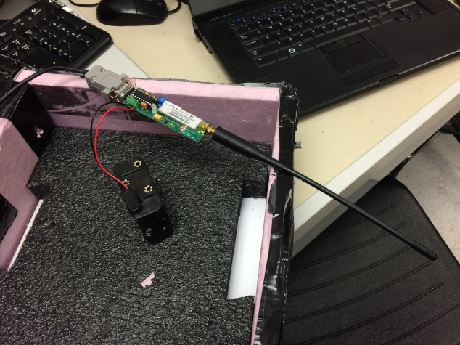

1)

3)

4) 

5)

2)

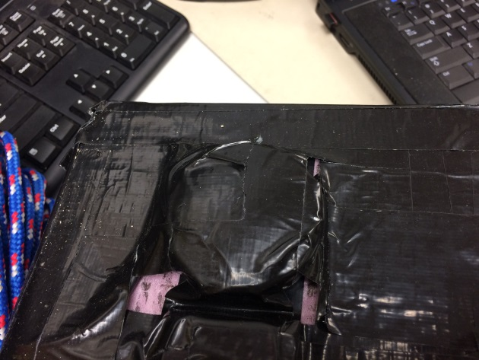

**2)**

* + - Habduino
      * Powered by 6 AA batteries (or anything with which an Arduino can be powered…. 6 AA will give you a sizeable lifetime), the Habduino is the successor to the Tiny Trak Transmitter. It will operate in the same realm of APRS packet transmission, but since it is Arduino, we can reprogram it as necessary and change the callsign and transmission frequency.
      * Once powered on, the Habduino LED will blink repeatedly. Then, as it searches for its first GPS lock, it will blink red. Once it finds that lock, it will blink green, and then return to blinking red. Once it has a second GPS lock, it will blink green and it will begin transmitting. The Habduino will not transmit packets if it does not have 2 GPS locks. If the Habduino is blinking green, it has 2 GPS locks, is transmitting, and is ready to fly.
      * 2 square GPS modules are currently strapped to the command module shell (as of 5/28/15), so 2 Habduino can be secured inside the command module shell. If more are desired, more square GPS modules must be attached.
      * Equipment includes
        1. Arduino Uno
        2. Habduino shield
        3. 2 antenna
        4. GPS attachment
        5. 6 AA batteries

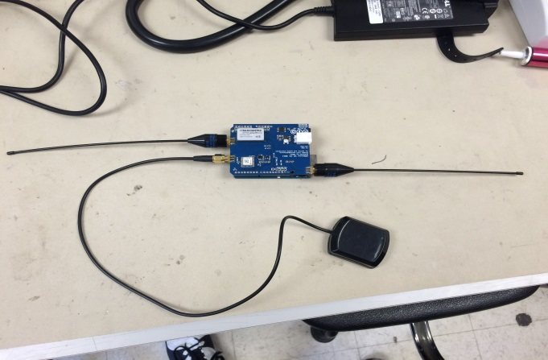  
  
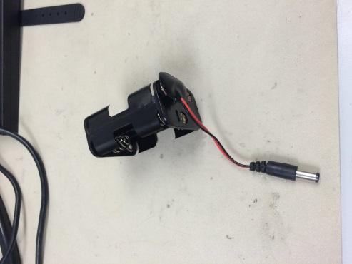

1) (underneath)

2) (Top shield)

3)

4)

5) (plugs in here)

5) (not loaded)

* + - Cell Module
      * The cell module texts its GPS location to a selected number, which can be extremely handy when searching for downed payloads.
      * (Cooper/Luke please insert operation and setup details please) pictures missing…
    - Securing Equipment
      * Place the transmitters inside the shell such that their antennas are sticking out of the shell. It is best if the antennas are outside the shell, but it is not essential.
      * Once everything is oriented appropriately, duct tape everything into place and make sure nothing will jostle around on the flight.
      * Duct Tape the shell closed
      * Place the shell in the orange pouch which is located directly underneath the payload strings hula-hoop, and use the pouch’s Velcro to shut the pouch.
      * For good measure, more duct tape can be used on the pouch to make sure the Velcro stays shut, but it may not be necessary. Can’t hurt though!

## New Setup

* This setup was first flown on NS-48 (first launch of Summer 2015), and it worked very well. It consists of two command modules, one which houses the APRS transmitters and one which houses the Cell Module. These are stacked on top of one another during launch, effectively increasing the size of the total “Command Module” setup.
* New APRS transmitters
  + 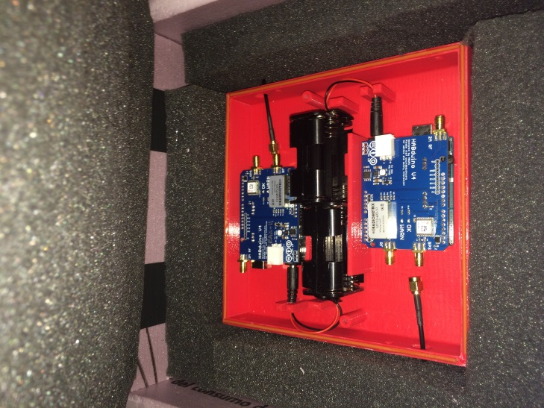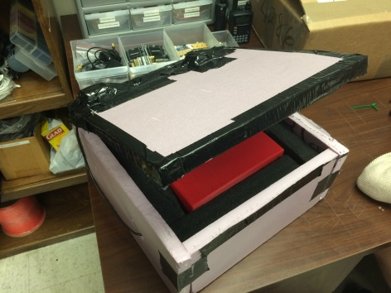
  + The new APRS transmitting housing has 2 GPS receivers mounted to the top of the outermost housing, and these receivers feed into the 3D printed structure inside the pink casing.
  + Inside the 3D printed structure, there is room for 2 Habduino APRS transmitters, as well as 2 6-pack AAA battery holsters. Holes have been drilled through the structure as appropriate in order to accommodate for the antennas used by the Habduino.
  + (Cooper or Luke can you elaborate more about the Cell Module and it’s housing here?)
  + When fully assembled, the two command modules will be inserted into their bags and hung from the parachute string as shown below.   
    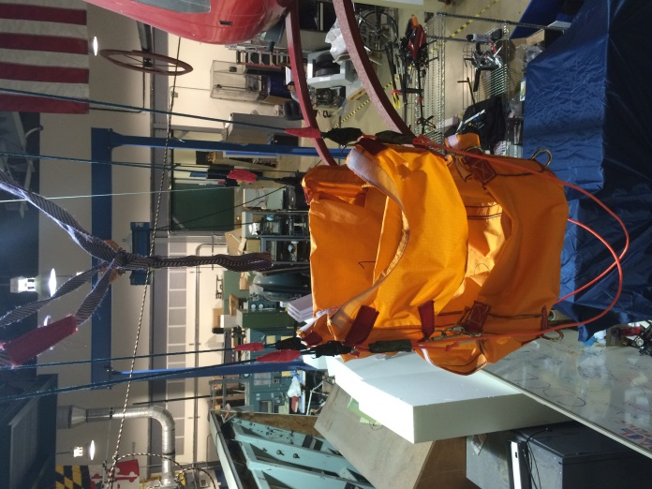

# Pre-Launch Checklist

Logistics:   
Housekeeping things that need to be done a week or two in advance…

* *One month before launch* – Confirm with Dr. Bowden that we have sufficient helium and balloons. These items can take a while to get so it’s good to stay on top of it.
* **Traditionally, Clear Spring Elementary School in Clear Spring, MD is the target launch time is usually 8:30am. We leave UMD Space Systems lab parking lot at 5:00am (That means everyone seated in the vans and physically leaving campus at 5:00am). Making sure everyone is packed up and ready the night before is important. Arriving at the lab between 4:00am and 4:30am to get everything loaded into the vans is highly recommended.**
* *1 week before* - Do weather predictions in order to find a good launch date and launch site
  + (See section on how to do weather predictions…)
* If you are preparing a payload… plan to have it finished at least 5 days before launch! Some payloads have had to cancel the night before (which can be a pain for logistics and predictions), and no one wants to do a launch with only a couple hours of sleep. Which brings me to my next point…
* Make sure you get some sleep the night before a launch!!!! Move deadlines up, go to sleep early… do whatever you need to so that you won’t have to do the launch dead tired. You can only run on redbull and coffee for so long, and trust me: when you’re fighting a tree to get your payloads back, or driving back to college park from the launch, you’ll be grateful for the extra patience a few more hours of sleep will give you.
* 1 Day before – Set up the Zello app on the teams iPhones. Download the app if you don’t already have it, as it can be crucial to keep in contact with the rest of the team.
  + Set up 2 channels – one for general communication amongst the whole team, and one for all the communications officers between all the vans.

**Have someone in charge of the Flight Director Checklist and make sure everything has been checked. The Checklist can be found below.**

## Flight Director Checklist

**Flight Director Checklist**

**NS-____**

**Launch Location = ________________________**

**Launch Date = ___________________________**

**Attempt Number = ________**

**Payloads:   ____________________________________**

**____________________________________**

**____________________________________**

**____________________________________**

**____________________________________**

**____________________________________**

**____________________________________**

**____________________________________**

**Parachute:**

**Comments:**

**One Month in Advance:**

___ Vehicle Rental (check that outlets work)

___ Helium Ordered

___ HAM Radio Club notified about using UMD’s call sign

**Launch Week**

**Pre-Flight Planning Checklist**

___ Launch Announcement Sent to Email List

___ Payloads Lined Up

___ Vehicles identified and configured for tracking

___ Weather Check

___ Ground Track Check

___ Create Zello Station

___ Print waivers

**Pre-Flight Systems Checklist**

___ Inflation Bucket (check Inventory)

___ Recovery Bucket (check Inventory)

___ Balloon

___ Backup Balloon

___ Batteries (check if charged)

___ Bow Saw

___ Broom

___ Cardboard Tubes

___ Extension Pole

___ Helium

___ Launch Kit

___ Machete

___ Multimeter

___ Parachute and Ring + Assembled Command Module

___ Payload String + Tubing

___ Phone Chargers

___ Power Inverter

___ Scythe

___ Sling Shot

___ Spring Scale (check batteries)

___ Sufficient Functioning Radios & GPS

___ Tarp

___ Tracking Antennas

___ Van Keys

___ Walkie-Talkies

**FAA Notification Checklist**

___ Notify Secret Service / Air Security Program ([ASP@usss](mailto:ASP@usss).)

___ File NOTAM (6 hours prior) via fax:  703-777-8807

___ Call NOTAM desk (866-225-7410 ext 9) to verify that fax came through and get assigned NOTAM number:

NOTAM # _____________

___ Call Washington Center (2 hours prior): 703-771-3470

___ Call HGR Tower 301-797-2039 at 7am

**Radios + Callsigns Checklist**

Command Module: ____________________________________________

Main tracking van: _____________________________________________

Second tracking van: __________________________________________

Specific payloads: _____________________________________________ ____________________________________________

____________________________________________

Capitol Technology University: ___________________________________

**Launch Day**

***Assignments***

* Still Photographer: __________________
* Video Photographer: __________________
* Payload Commander: __________________
* Balloon Controllers
* Tether Line Handlers
* Clean Up Crew
* Navigators for each Chase Vehicle

***Pre-Launch Meeting***

* Everyone should have signed a waiver
* New ones collected; Sign-In sheet for other visitors
* Everyone needs to decide right now where they are going after the launch: chase, HCC station, or home?
* Chase Vehicles will need to leave semi-immediately (so go potty now and be ready to leave right after release)
* Those who are not chasing should stick around long enough to clean up and secure everything

**Final Checks**

___ Weather Check

___ Ground Track Check

**Vehicle Integration**

___ Parachute to Balloon lanyard configured

___ Parachute and Ring assembled

___ Command Module in place

___ Payload string lined up and assembled

___ “Harmless” tags on payloads

___ Payload string weighed: Necessary Free Lift = _________

___ Antennas clear

___ No sharp edges, no weak links

**Pre-Inflation Checklist**

___ Helium Tanks uncovered and regulator hooked up

___ ***Hook lanyard from chute around balloon neck before connecting to inflation tube!***

___ Instructions and Gloves to balloon handlers

___ Instructions given to tether handlers & tether in place

___ Full payload string laid out and ready to go

___ Get lift measuring setup in place and measure total lift as needed

**Inflation**

Start inflating at max flow rate

Inflation Complete: Measure Total Free Lift = ___________

**Pre-Release Checklist**

* Clear to Launch (Range Safety)
* Payloads Ready (Payload Commander)
* Tracking Good (CapComm)

**Countdown & Release**

___ All Payloads Switches On

___ Raise Stack above pad in full flight configuration

___ Telemetry and Downlink good

___ Tether handlers ready

___ Photographers ready

___ Countdown from 10

___ Release

Release Time Mark = ______________

Initial Heading of Flight = ______________

**Chase Teams**

Chase 1: Pilot =  ____________________

Navigator =  _______________ Tracking = _________________

Communications Officer =  _____________

Back Seat 1 =  _____________ Back Seat 6 =  ______________

Back Seat 2 =  _____________ Back Seat 7 =  ______________

Back Seat 3 =  _____________ Back Seat 8 =  _____________

Back Seat 4 =  _____________ Back Seat 9 =  _____________

Back Seat 5 =  _____________ Back Seat 10 =  _____________

Cell Phone Number:  __________________

Chase 2: Pilot =  ____________________

Navigator =  ________________ Tracking = _____________

Communications Officer = ______________

Back Seat 1 =  _____________ Back Seat 6 =  ______________

Back Seat 2 =  _____________ Back Seat 7 =  ______________

Back Seat 3 =  _____________ Back Seat 8 =  ______________

Back Seat 4 =  _____________ Back Seat 9 =  _____________

Back Seat 5 =  _____________ Back Seat 10 =  _____________

Cell Phone Number:  __________________

Cars:

# Weather Predictions and Predicted Landing Sites

Before we give the go-aheads to a launch, we must run some predictions – depending on the weather (particularly the wind) and the time of launch, our payloads could land anywhere from a clear, accessible field (haha, like that ever happens), to the tallest imaginable tree (every. single. time.), to a river (oh no, backup, backup, backup… we don’t want that to happen), to a highway (hasn’t happened yet, phew), to 4 hours away in PA (the longest we’ve ever had was 2.5 hours…horrible), etc.

If you don’t want any of the horrible landing sites, you gotta check the predictions beforehand. Of course, there’s only so much you can predict, but we’ve got a website that’s gives pretty reliable and accurate landing and ground track predictions. You should run them a week in advance, the day before (to give the go-ahead), and the morning off. This website also includes a burst altitude predictor, which helps us know how much helium we should put in the balloon in order to reach a certain height, given our payload mass and balloon size.

Website: <http://predict.habhub.org/>

Input information:

* Coordinates of Clear Springs, MD: 39. 65676° N, 77. 93417° W
  + Input: 39. 65676 / -77. 93417
* Launch altitude:  174 m
* Launch time (UTC):
  + In summer, UTC is 4 hours ahead
  + In winter, UTC is 5 hours ahead
* Ascent rate: It really depends on the total payload weight, but it’s usually between 5 and 7 m/s
* Burst Altitude: 24000 m (average)
* Descent Rate: 15 m/s (average)

*A prediction cannot be run for a time that is more than 180 hours in the future.*

# Prepping the Payloads for departure

## General

This is a time to test startup systems for all payloads and make sure everything is in working order. Make last minute adjustments, and secure the payloads to the string, and make sure tracking is in order.

## Tracking Tests

* While the other payloads are being prepped, tracking must be tested. **It is critical that there be at least 2 working APRS transmitters aboard the flight! If tracking does not have at least double redundancy, the flight cannot commence.**
* To test the tracking, tell all APRS transmitting parties to turn on their transmitters.
* Once the transmitters are on and have GPS lock, power up the tracking van ground station.
* Assemble a list of callsigns
* When a callsign is heard on the radio with a good packet (see the “Identifying good packets” section for details), and plotted on the GPS, it can be marked as “ready to fly”. Ideally, you want to mark off all the callsigns on the list as “ready to fly”. If a transmitter on the list is not spotted after a time, investigate the problem. Again, the flight needs 2 functional APRS transmitters which are “ready to fly” in order for the flight to commence.

#### Identifying packet types

##### Partial Packets

There are two kinds of packets you can get from an APRS transmitter. One is a *partial packet*. You can tell you have received a partial packet from when your ground station gives a modest “beep-beep”, and the D700 panel displays a callsign *without* an associated altitude (the altitude will read zero).

A partial packet is something you will most likely see while you are testing in the parking lot of SSL while your transmitter is trying to acquire GPS lock, or if it cannot find a digipeater tower to reflect off of. Sometimes partial packets will give you a position and even plot on the GPS map. Most of the time, they are not what you want to see from your transmitter, but they are definitely a step in the right direction and it means that either your transmitter doesn’t have a full GPS lock yet, or your line of sight between the ground station and the transmitter is bad. During testing, you can try to make the line of sight a little better or place the transmitter in a place where it is known that you can acquire GPS lock. For ground station testing at SSL I recommend placing the transmitter in the open amphitheater-looking area behind the animal science building… I usually can get GPS lock over there, though you might have line of sight issues…

But if you are having these problems on the launch pad, there is little you can do about it. If you have spent ample time on the pad trying to get one transmitter working (that had previously been working fine the night before) I recommend moving on to the others before wasting too much time. Sometimes they work fine once they are in the air. But, *do not* mark it as “ready to fly” if you don’t get a good packet from it before launch. I.e. do not count it as one of your two APRS transmitters which are needed to start the launch.

**Update: Further reading on the systems suggests that the “partial packet” signal (ex: “dP W3EAX-9”) indicates a duplicate position comment. See the manual for more details…**

##### Good Packets

The other kind of packet you can get is referred to as a *good packet*. You will know you have received a good packet when you your ground station makes a “BEEP-BEEP-BEEP” sound. The D700 panel will display the callsign of the good packet, along with an altitude which is not zero. The key to telling the difference between a good packet and a partial packet is the difference in the beeps from the ground station, and whether or not the panel displays the packet with an altitude or not. If the altitude reads zero, the packet it partial, indicating that the GPS is not locked. But if the GPS is locked, the altitude will read a nonzero value, indicating a good packet.

*Sidenote: these might not be the literal sounds the ground station makes, but the good packets will have more beeps, and those beeps will be louder and more solid. The partial packets will be shorter and more modest. After a bit of practice, you’ll quickly learn to hear the difference!*

The following is an example of what you will see on the D700 display panel if you receive a good packet from an APRS transmitter. Notice what the altitude readings look like

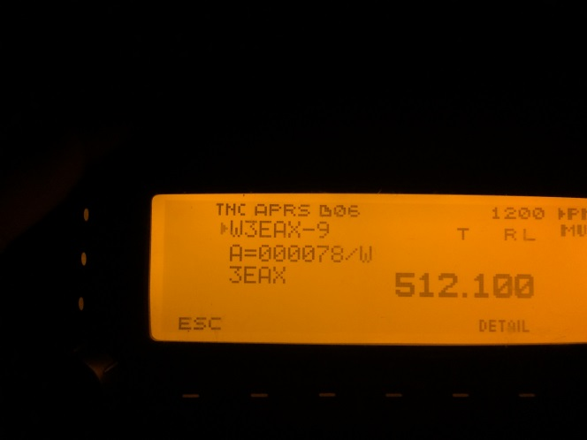

This picture is typically what you will see with a good packet. It clearly states the callsign and the altitude (A=000078). The non-zero value of the altitude tells us it is a good packet. If the altitude had been zero (A=000000), we would know the packet it partial. You can sometimes still get position from partial packets, but you will need good packets to clear a transmitter for launch.

# Active Tracking Instructions for chasing your payloads

The payloads are off!! You’re on the tracking team ready to chase them! Here are some tips and tricks to keep things running smoothly

The Tracking team – key players for tracking van and their bio-blasts:

* Driver – Keep your eyes on the road and listen to the navigator, and stay focused. Safety is the number one priority. Getting the team there in one piece is your one job, don’t worry about tracking or navigation, just follow the instructions from the navigator
* 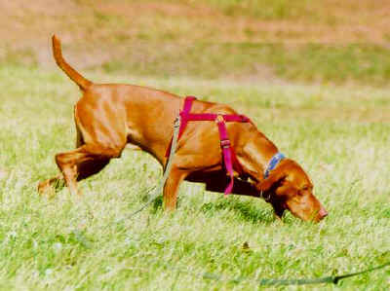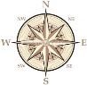Navigator – coordinate with the tracker and active predictor to find the best route. This person will need to use their phone in order to navigate to the predicted landing site. The navigator will need to update the route as needed and be in constant communication with the driver. Navigator (and company) will need to strike a balance between getting to the predicted site as fast as possible and also not overshooting the landing site.
* Tracker – Tracker is in charge of the ground tracking station. Follow the progress of each of the APRS trackers and announce altitude and important location information to the rest of tracking van. Coordinate with navigator and active predictor to determine the best heading for the tracking van. Balloon will most likely burst around 70,000-80,000 feet, so be mindful of altitude changes around these altitudes!
* Active Predictor – Actively predict the new landing sites for the balloon based on information from the tracker. Coordinate with tracker and navigator in order to determine the best heading for the tracking van. (Steve Lentine created the active prediction software, see him for more details)  
    
  * - “I see trees in your future…. Lots and lots of trees…”*
* Communications Officer – In charge of communicating to other cars what the current situation is. This job is critical in order to keep the rest of the team up to date. Comms officer will contact other cars (via the Zello app most likely) with updates on altitude, tracking van heading, and balloon positon. Of all of these, the most important is tracking van heading. You will be responsible for telling the other vans what the next turn is, as well as telling them where the “final destination” will be (the “final destination” will probably change frequently based on updated predictions). ***EVERY CAR SHOULD HAVE A COMMUNICATIONS OFFICER WHO IS IN CONTACT WITH THE TRACKING VEHICLE AT ALL TIMES!!***
* The Watchers – Those who are not an active predictor, tracker, driver, navigator, or comms officer are designated Watchers. BUT. This is a critical position as well. It is a Watchers job to keep their eyes on the balloon for as long as possible, both immediately after launch and as the landing site is being approached. Take pictures, video, and other things of the entire process! The prepping, the chase, the recovery…. Documentation is crucial!   
  Also…. The drivers can’t always see cops so if the Watchers need to keep an eye out for police as well ☺

# Approaching the landing site

## General

You’ve successfully tracked your payloads and know where they touched down (hopefully). Good job!!!

But… most of the time you can’t just go up and grab them. Is it an open field? It’s probably owned by a farmer. Is it woods? Check for a house. Public Park? (yea right when have we ever been that lucky…)

It’s very important that at the landing site you always search for some figure of authority. ***ALWAYS GET PERMISSION BEFORE GOING AFTER THE PAYLOADS***. There are a few rare circumstances where the payloads land in an unpopulated area and there is no one to approach. In this case, double, triple, quadruple check that you won’t be intruding on anyone’s property or into a restricted area! Recovery can sometimes take a very long time, and if you are on someone’s land for that long, you should have permission.

## Approaching the house and getting permission

Imagine you’re at your house, and you see a big parachute with a bunch of boxes make a not-so-graceful landing in one of your trees. About 10 minutes later, 3 large white unmarked vans pull into your driveway and 30+ students come pouring out and running all over your yard, looking for the boxes, carrying a bunch of saws and ropes and a giant slingshot…   
Let’s not do that.

Instead, follow this procedure…

1. Locate the residence/facility
2. Make sure that only one van approaches the residence/facility (most likely tracking van) and let the others stay just off of the property.
3. Choose two ambassadors. One upperclassmen, like a Junior or Senior (to take the lead), and one lower classmen, like a sophomore or freshman (for the experience). ***Everyone else must remain in the van. Until the ambassadors come back and tell you otherwise, stay in the van.***
4. Politely approach the homeowner or worker and explain the situation.   
   “Hello, how are you? My name is (…), and we’re a group of students from the University of Maryland. This morning we launched an experimental weather balloon from Clear Spring and our tracking equipment tells us that it (may have) landed somewhere on your property, do you mind if we have a look around?”   
   Be very polite and answer any questions they have. If you’re lucky, they might just be able to lend you a hand!
5. If the owner of the property is not home, look for neighbors and repeat the procedure. Ask if you think the owner would mind if you had a look around his property.
6. Once you have permission, the rest of the team may move in and begin looking for the payloads.
7. In the event that you do not receive permission, thank them for their time and report back to Dr. Bowden. We have never had that situation before, though I’m sure that if it occurred, the group could come up with something to convince the property owners.
8. If no one is home and there are no neighbors to talk to, cautiously proceed onto the property to recover the payloads and leave a few people near the front of the house to wait for the owner if they come back.

# Retrieving the payloads

* Make sure you have all the retrieval equipment necessary before venturing after the payloads. See the list below for forest/tree recovery….
  + Duct Tape
  + Work Gloves
  + Machete
  + Rope saw
  + Hacksaw
  + Bright orange vests
  + Slingshot
    - 3 pieces (lower shaft, upper shaft, slingshot head)
  + Slingshot bag
    - 1-2 bean bags
    - Nylon string
  + Heavy rope (2-3)
  + Scissors
  + Knife
* When in doubt, bring the whole recovery bucket!!!!
* Standard approach for tree recovery
  + Assemble slingshot
    - Insert upper shaft into lower shaft
    - Insert slingshot head to upper shaft
    - Untangle the nylon rope from the slingshot bag
    - Double knot the nylon rope to the beanbag
  + Shooting the slingshot
    - Make sure the rope is coiled such that the entire coil will not go flying when the bag is shot.
    - Find a clearing where you can launch the slingshot from, clear of brush (use machete) and overhanging branches. Make sure you know the limits of the slingshot.
    - Operate the slingshot with one shooter. 1-2 assistants can help to steady the pole.
    - Place the bean bag on the slingshot pouch and feed the line over the top of the slingshot. Make sure the rope coil and the line are both in front of you whenever you shoot, or else you might get ropeburn! Or the rope could get caught on something on its way up
    - Make sure you practice!! It’s the best way to gage and get a feel for where the beanbag will go.
    - Most of the time, there are 2 distinct targets. Use your judgement on which one would be more beneficial to get a line around
      * The payload hula hoop
      * The branch on which the payloads are stuck
  + Once you have used your incredible marksman skills to get a line on the rope, tie the end of the nylon rope to a heavier rope, and pull the nylon over the branch until the heavy rope is looped around the branch
    - If you put too much stress on the nylon rope, it will snap. Also, working the nylon back and forth over a tree branch causes the branch to cut through the nylon and you will lose your line. A heavier line is much more practical for shaking branches and tugging at payloads since it is thicker and can support more weight.
  + If you’re lucky, the payloads will come tumbling down if you….
    - Shake the branch vigorously
    - Pull really hard on the payload string
  + Using the rope saw (If you are looking to cut a branch) (This section will probably need to be updated after a few uses once the technique is mastered)
    - As of yet (5/28/15), the rope saw is untested. The concept is simple enough though…
    - CAREFULLY uncoil the rope saw
    - Tie the rope saw to one end of your first heavy rope (the one which has a line to the tree) and then tie the other end to another heavy rope
    - Lead the ropesaw up the tree by pulling on the heavy line which is already on the tree. Keep pulling until the saw is on the tree branch.
    - For safety reasons, make sure the area is clear of anyone who is not immediately involved with the rope saw operation. Also make sure that whoever *is* operating the ropesaw is clear of the landing site of all debris.
    - Those who are not cutting the branch are on “watch duty”. If you see someone who is in danger, call out their name specifically (instead of a general “hey watch out”, it’s better to specifically say “JOE look out”), and warn them of the debris.
    - Pull back and forth on both on the heavy ropes in order to cut the branch. Be mindful of falling debris.
    - Once branch has been cut and all the debris has landed, hopefully the payloads can be recovered.

# Launch Accounts

## NS-44 Log (Fall 2014)

### Bryan Hetzer’s account:

After wrestling with the old tracking system again, I’ve finally figured out and documented how it works. Woo!!!!

We launched out of Clear Spring, MD, at Clear Spring Elementary School, the traditional launch site.

After this launch, we have now had significant tree-trouble 3 times in a row. Much of the ride home was spent figuring out how we could prevent these giant leafy monsters from keeping us from our payloads… Here is what we came up with:

* GET A ROPE SAW
  + Coupled with the Slingshot loop-and-pull-and-shake method, we would tie a rope saw on the end of the string and loop it over the branch, cutting it down and (hopefully) bring the payloads tumbling down with it.
* Tree Climber “on call”
  + The sure-fire way to make sure you get the payloads? Call a tree climber. Nothing wrong with this method except that it might cost a little more money to get him to come out. Also, if he isn’t expecting to come out on the day of the launch, it might take a day or two to get the payloads back….. Maybe try getting him to be “on call”
* Rescue Payload
  + Kyle Kaplan is designing a payload which will deploy a string remotely. Or maybe he has other methods! Stay tuned
* Mini-cutdowns
  + Remotely activated cutdowns in between the payload string…. Probably not this idea, because it adds a lot of weight and another element of danger. But, who knows? Maybe we can find a way to make it work!
* Lighter payloads
  + The sum of the payload weights contributes to where it lands. Lighter payloads mean a longer flight, possibly to a less tree-infested area!
* An easier way to untangle the slingshot line
  + Whenever we use the slingshot, it always takes about 20 minutes (at least) to untangle and lay out the line that will be shot at the tree. Also, after each shot, if it is a failed attempt it takes a long time to retrieve the string. We need a better method to get as many slingshot shots at the payload as possible!
* Slingshot practice
  + Practice Practice Practice Practice Practice Practice Practice Practice Practice (They say it makes perfect…. Practice)
* Cardboard tubes
  + This one I’m particularly excited about (Props to Cooper!!). In between each payload, we insert a cardboard tube around the string. This will keep the line rigid, and instead of lying across the top of a tree line, we will hopefully penetrate it and be hanging lower (within arms-length, please??)
* Saw/chainsaw/Machete
  + Bring one with you on recovery. Sometimes shrubberies need to be cut down to allow for better slingshot shots, equipment setup, etc.
* Long string “tail”
  + Easy: leave an excessively long string attached to the bottom of the payloads! We could grab onto the string and pull everything down. Perhaps attach a softball on the end of it?
* Bright colors (not autumn colors) on payloads
  + Make for easier location. Pink, White, bright blue…. Anything but green and orange and red. Or, if you do fly those colors, make sure the payload colors aren’t the same color as the trees (season dependent).
* Bow and Arrow
  + Same concept as the slingshot, except just get some luck Hawkeye or Legolas to shoot and loop the payloads via an arrow with a string attached.
* Lax ball and stick and string
  + Slingshot idea, except with a lax ball and stick. Drill a hole in the ball and insert the string, then take your best shot at the payload. Recommend that the ball is also not the same color as the foliage…
* Baseball and string
  + Lax ball and stick and string, except with a baseball
* New launch sites
  + Change the launch site! We can predict where we land, so why not change the launch site such that we *don’t even land in any trees*?? Might just be crazy enough to work.

## NS -47 (Spring 2015, Launch 2)

### Bryan Hetzer’s Account

* Several Successes on this launch!
  + Supersonic had its first successful static line test. It reached a height of approximately 5,000 ft before successfully cutting itself down and deploying its parachutes. The payload landed safely in a Clear Spring field. Recovery team retrieved payload and went on to join the rest of the Nearspace team to find the main string.
  + Several new tracking successes, which are now flight tested and can be used in future flights independently of old transmitters
    - Habduinos were successful (Tested and approved replacements for the “tiny track” transmitters in the near future)
    - Cell phone shield was successful (sends texts to someone once it has touched down, which sends the GPS co-ords of its location. This is very useful once the payload has touched down, as the APRS tracking becomes faint once the payload has landed)
  + SPECTRE – Testing of Solar Power throughout the flight – Data successfully acquired
    - Aspiring ideas of powering a component or system on the launches to come – possibly minimizing SPECTRE as a whole and being able to attach it as an outside component to another payload which needs power
  + Bach’s Box – Weather Payload
    - Pressure, Temperature, Dust concentration, Humidity, Altitude, Density, and other weather data were successfully collected
  + CTU payloads – Hermes, TRAPSAT, QUBESAT –
    - QUBESAT – unsuccessful due to use of “Big Red Bee” APRS transmitter
    - Hermes and TRAPSAT both successful
  + Space Heater – Temperature regulating payload: data successfully acquired
* Quick and painless recovery
  + Luke’s Cell Shield performed flawlessly for a second launch in a row, telling the team the exact coordinates of where the payload would be located, making a short search time. That’s 2/2, and a MUST HAVE on all launches from this point out, in my opinion.
  + Neel “Showtime” Patel came in clutch for the Nearspace Team today as he demonstrated his expert marksman slingshot skills but looping a line around the payloads. The team was able to bring down the payloads shortly after arriving at the landing site, thanks to his excellent shot.

## NS-48 (Summer 2015, Launch 1)

### Bryan Hetzer’s account

* Payloads flown:
  + BADASS
    - Host payload
      * Temperature (thermistor)
      * GoPro
      * IMU (stabilized)
    - IMU (un-stabilized)
    - Temperature (thermistor)
  + Black Box
    - Atmos
    - IMU (x2)
    - Xbee logger
  + Looking Glass
  + Spectre
  + Command Module (x2)
    - APRS transmitters
    - Cell tracker
* Results
  + BADASS
    - Host Payload – The microSD card seemed to be damaged upon impact (a small crack across the bottom of it) and now it cannot be read by any computer. This means the host payload data about
    - IMU (un-stabilized) – unknown
    - Temperature (thermistor) – unknown
  + Black Box
    - Atmos – assumed successful logging
    - IMU (x2) – assumed successful logging
    - Xbee logger – unsuccessful logging
  + Looking glass – battery was very short…. Shortly after powering on, the battery life was rapidly drained and resulted in only 5 minutes worth of still frames. Project unsuccessful, all ties with bublcam are to be severed and all orders canceled and refunded. >:/
  + Spectre – assumed successful logging
  + Command Module (x2) – APRS tracking successful. Packets transmitted at 1 minute intervals as opposed to 30 second intervals, and this proved successful. This is the first flight on which the Habduinos were the only APRS transmitters aboard the command module, and they worked very well. On a separate note, for some reason my car’s tracking system did not track the payloads very well. It tracked the other cars well, and the other cars saw most of the balloon packets. For some reason my ground tracking station wasn’t doing very well… The Cell module worked perfectly.
* Overall recap
  + We launched from Clear Spring Elementary at 8:14am. The balloon had a slow ascent rate, and we regrouped at a Middletown McDonalds in order to track its slow-moving progress. While we waited and tracked, we saw the balloon reach 90,000ft, an altitude that has not been attained for the last couple of years. Landing occurred near Boonsboro, in a cornfield. This allowed for a very easy recovery, and a quick end to the launch day. The team had some great pizza in Boonsboro, and was able to return to college park by afternoon. Good launch!

# Ongoing Research

## Laptop APRS plotting/tracking Materials

#### Radio

TM-D710G Radio [Item 13]  
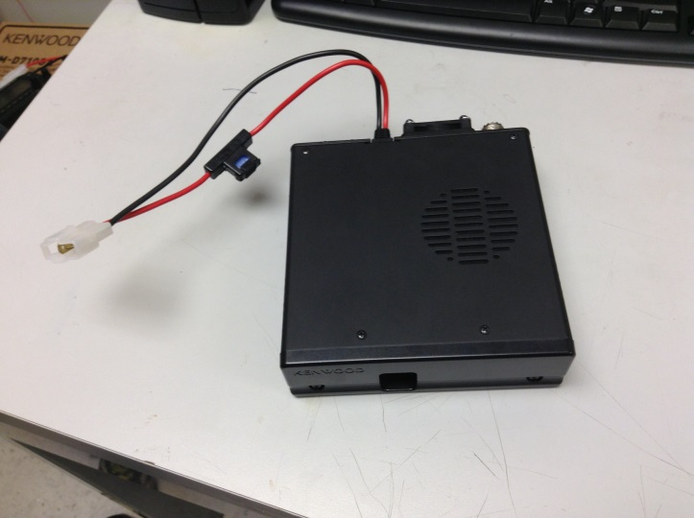

|  |  |
| --- | --- |
| Tracking Antenna  (Labeled : Tracking) [Item 2]    **We have 2 tracking antenna at the lab, both can be used on any tracking setup**  GPS  Lucky for us, there is a GPS installed in the TM-D710G! It can broadcast our position, if the TNC (panel) is programmed correctly.  “Ethernet-like” cable  Used to connect panel to radio [Item 15]  Power/Gnd Simple car-outlet-to-radio power setup [Item 16] Com cable This Com Cable will allow for the 710G to feed APRS packets directly into a laptop via serial feed. This will be useful later when the laptop mapping programs are operational. [Item 17] Laptop If there isn’t one for the lab, then you’ll need to use yours and get the proper software….. Software includes:   * CoolTerm (for testing purposes) * (anything they’ll need here, Nick?) | Panel FM Dual Bander TM-D700 (Kenwood, Label : Tracking Vehicle TM-D710G Display) [Item 14]  On the right side – 2 double knobs – base knob controls squelch, higher knob controls volume |

### Assembly

* Plug antenna [Item 2] into back of the radio [Item 13], and screw it in to secure it
* Take the car plug from [Item 16], and plug them into the car outlet
* Attach the red and black cables from [Item 16] to the red and black cables from the radio [Item 13]
* Plug in the Com Cable [Item 17] into the back of the TNC panel [Item 14], and insert the USB into your laptop.
* Connect the TNC panel [Item 14] to the radio [Item13] using “Ethernet cord” [Item 17]

### Operation

#### General Operation

* If you’re lucky, the settings should be all set up already. PM1 should have everything ready to go…
* Open menu (press F then press in on the leftmost knob)
* Go to APRS and press in on the leftmost knob
* Use the leftmost knob to scroll through the APRS settings, and find “COM PORT”. Select it.
* Make sure that the OUTPUT setting is ON
* Go back to the main screen
* Make sure that APRS12 is displayed in the upper left of the panel. If it is not, press TNC until it is. This will enable to TNC and you can now receive APRS packets. (You COULD set the TNC to PACKET12 mode by pressing TNC one more time, but this does nothing to change your output and mutes the sounds/alerts of incoming packets on your panel. You’ll still be getting good serial feed, so you can change to PACKET12 if you get annoyed with the packet updates)
* ****** Everything from here on out is just how I have been getting testing data to assist Nick in developing the program*****
* Fire up CoolTerm on your computer
* Select Options, and make sure you have the correct com port selected. The Baud Rate should be 9600
* Make sure the Habduino and the old transmitter are sending packets
* Make sure you are receiving packets on the ground station setup
* Turn off the ground station setup (in order to make sure we capture all boot-up serial activity at the time of recording)
* Go to Connection
* Go to Capture to Text File and press start
* Find a place you wish to save your test file (and name it too)
* Then, press connect and power on the ground station
* Let the system sit and collect information for however long you need to. The Habduinos (As of 6/30/15) can only transmit in 1 minute intervals and the old transmitter sends once every 30 seconds.
* When finished, press disconnect
* Go back to Connection, Capture to Text File, and select Stop
* Go view your new text file and make sure everything came out ok

### Testing results

* Initial testing proved to be troublesome, it took a long time for the radios to communicate with each other due to coding difficulties.
* The 900 Mhz radios utilize frequency hopping, meaning they bounce around in a range of set frequencies looking for another 900 Mhz module to match up with. Once it has found a match, they begin communicating and data can be transmitted.
* Because we owned four different 900 Mhz radios, when they were all powered we got problems about which radio should transmit to which radio. Therefore, we had to use the radio programming software (RFD Tools) to program one pair of radios to only hop between 902-914 Mhz and then the other pair would move between 916-928 Mhz. This way we avoided interference and were able to designate a “radio 1” and “radio 2”. (As a side note, both radios operate on a 9600 baud rate)
* We were having a lot of trouble trying to get both radios to transmit simultaneously, and it was believed that improper programming was the cause. Using an Arduino Mega, the ports of TX0/RX0 and TX2/RX2 were used for this experiment. TX0/RX0 corresponds with the “Serial” port of the Arduino Mega, and is the standard Serial port that is found on every Arduino. TX2/RX2 is associated with the “Serial2” port, which is a special feature of the Arduino Mega. The mega allows the Arduino to utilize multiple serial ports for TX/RX communications.
* The problem was that we were able to hear a pair of radios whenever they were connected via “Serial” (TX0/RX0), but not when they were connected with “Serial2” (TX2/RX2). The same IMU data was being output to both Serial ports, yet only radio 1 (the radio associated with TX0/RX0) could be heard. Either garbage data or silence could only be heard on radio 2 (the radio associated with TX2/RX2). After fiddling with the baud rates, and trying several different iterations of code, we were still at a loss as to why the Arduino wouldn’t play nice and just transmit the data on both radios. The radio pairs were swapped between serial ports regularly (the 902-914 radios were used on “Serial”, the 916-928 radios were used on “Serial2”, then they were switched back and forth several times to ensure the problem did not lie with the radios themselves). Still, we found no success with radio 2.
* WARNING: BLACK MAGIC AHEAD (but khalessi, it is forbidden!!!)
  + So. Black magic… after testing the radios on the oscilloscope, and trying to interpret the nature of the waves they output while transmitting, there was a happy accident.
  + The RX2 pin of accidently came in contact with the RX pin. Oddly, radio 2 was transmitting now. Further experimentation revealed that the same result can be achieved if the RX2 pin comes in contact with the TX pin. The black magic part? Noone knows why this makes it work. But… both radio 1 and radio 2 are now working. And so, if a black magic wire must be flown then it must be flown. Dothraki be damed.
* The first flight of this 900 Mhz radio setup will take place on July 18th, on NS-49.