**POST HAB LAUNCH REPORT**

By Kimberly Frost

**Payload Description:**

Tested the first iteration of TriggerMode on an RPI Zero W during a HAB flight. The flight testing done prior to flight was a thermal test of the 3D printed frame, structural test, and thermal test of the RPI with the LSM303 and TSL4531 digital sensors.

**Flight Description:**

Released from Harper’s Ferry Middle School at approximately 8am on November 16th, 2019. Reached a max altitude of ~85,000 ft and a flight duration of two hours. The experiment was successful in functioning, collecting data, and surviving the launch.

**Results**

**Trigger:**

Triggers were set as static values that between two compared data points caused the entrance into burst mode. The LUX trigger and IR trigger each went off once, at the same time stamp. This calls for either increasing sensitivity or inaccuracies due to being obscured. Acceleration and magnetic field triggers went off 2,872 times and 1,612 times respectively. All triggers should be adjusted accordingly to prevent this mass triggering of 4,486 times in two hours.

**Structural:**

The designed cage frame survived the launch with no resulting damage.

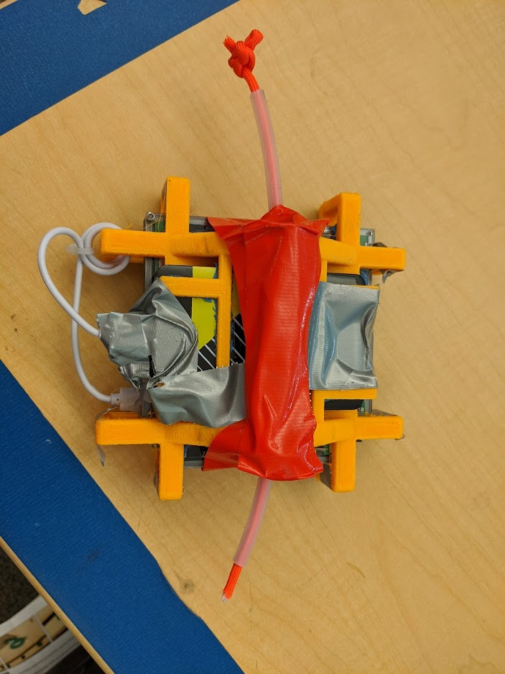

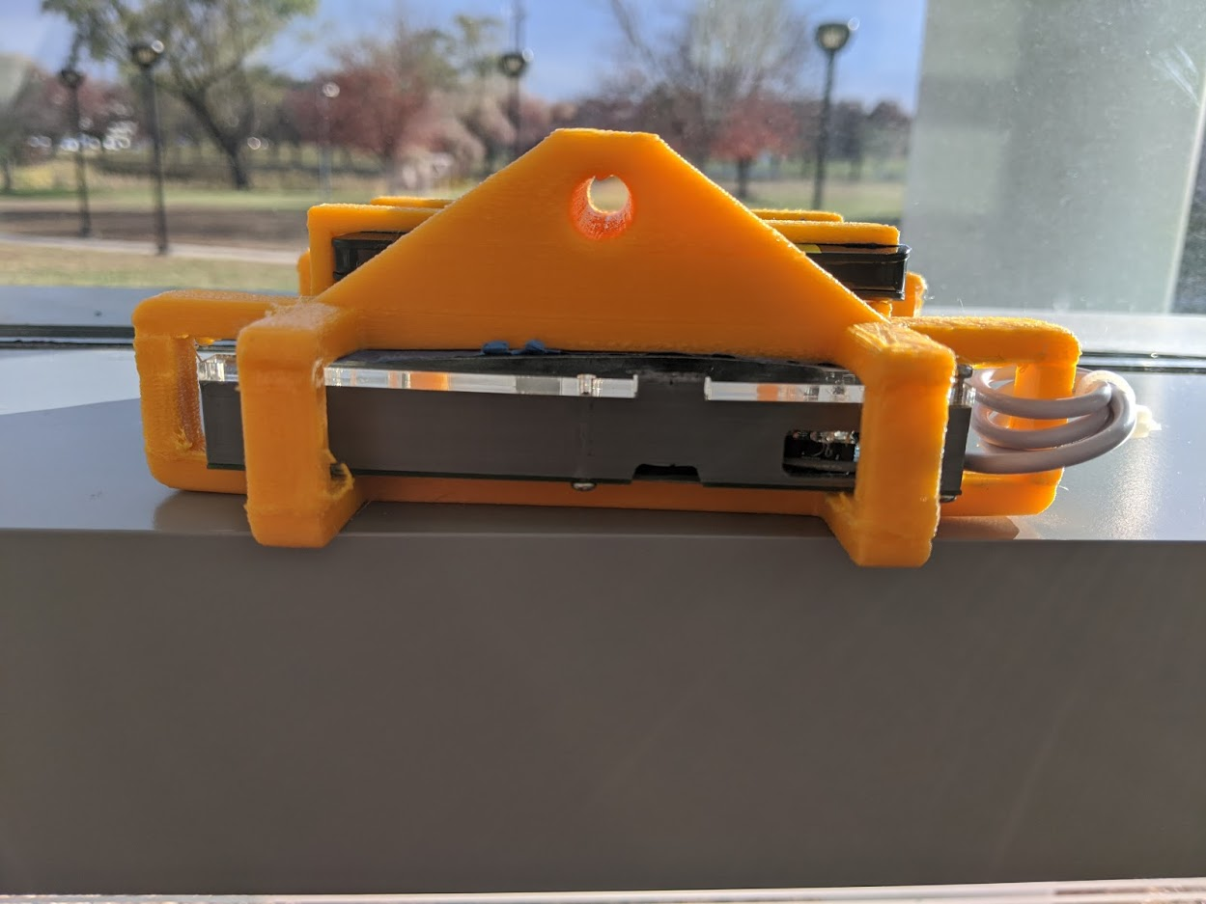

Picture 1 Pre Launch Condition

Picture 2 Post Launch Condition

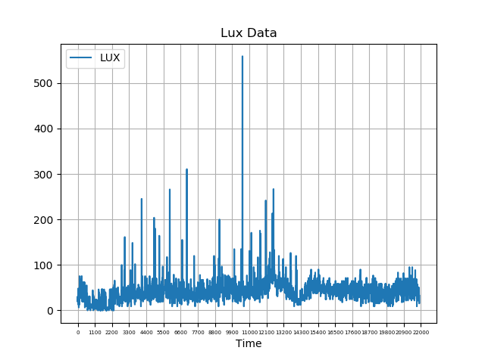**Data Analysis:**

The average reading was ~75 lumens (equivalent to a dimly lit room) and a peak of 500 lumens(a moderately lit room). Expected values were closer to that of direct sunlight of ~90,000 lumens. The data collected on LUX level, leads to the conclusion that the sensor was obstructed; the physical sensor was in near darkness for much of the flight and experienced brief indirect light periodically.

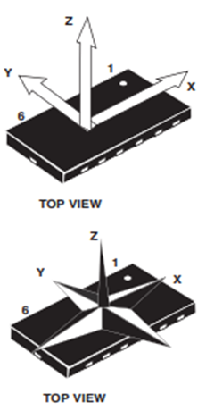

Figure 1 LUX Data collected from file

The LSM303 sensor collected data on the magnetic field and acceleration of the payload in three axes. The axes labelled are according to the sensor oriented flat on a table, even though that is not the actual orientation of the sensor.

Picture 1 Orientation guide from data sheet of sensor (left)

Picture 2 Orientation based on physical mounting (above)

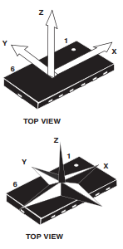

In the graphs below the Y axis will show direction and magnitude of the payload’s rotation about the rope. The X axis will denote vertical movement, such as the ascension and descension of the payload’s altitude. The peak altitude reached can be seen when the X axis acceleration reading equaled zero at time stamp 2458 and the values transitioned from positive to negative. The Z axis data reflects the shaking of the payload normal to the rope; essentially the payload swinging. Later data point may include the attempted removal of the payload after getting caught in a tree.

All magnetic field data collected is much higher than predicted; normally the Gauss rating at the Earth’s surface is about 0.5 Gauss while the magnitude of the recorded strength (Figure 9) averages ~800 gauss. Accuracy is subpar. As well, high fluctuation of data point values between timestamps 184043 and 184127 is unexpected.

**Errors:**

Figure 10 is the recorded time stamps over time. Fluctuation in slope is the entrance and exit from burstmode. The drops and jumps in the y axis are due to program restarts causing the inaccuracy of the timestamp reading overall.

The program rebooted multiple times during flight, evident in Figure 10. In all other graphs invalid data points appeared as zero since the header was present upon every restart; those values were all remover. A possible cause for rebooting could either be the RPI restarting or program erroring out and restarting.

In the Error Log there is an almost continuous error on the IR sensor leading to concern on validity of the IR results and a possible cause for the program restarts. The error occurred a total of 11,156 times during the course of the flight.

**Conclusion**

There were major successes for the inaugural major test of TriggerMode and there are clear refinements to be undertaken. The IR error needs to be addressed and the sensitivity of the triggers need to be adjusted. Determining the cause of the rebooting is essential to get better data on the success of the burst mode. There might be data corruption to due sudden stops and starts, if there is it is evident in the collected magnetic flux graphs. However unlikely, the graphs might be due to missing a function to convert the data into gausses or interference from another payload on the rope that had a local magnetic field.

Future iterations could do a percentile difference as a primary trigger and a static value as a secondary backup trigger; as there will be an issue with the percentile method when 0 is one of the compared data values. Additional components to be added are more sensors, triggers, and modes. A possible variation of TriggerMode is one that runs on the Xchips hardware in place of an RPI Zero W; it could be looked into for future models or as a side experiment.

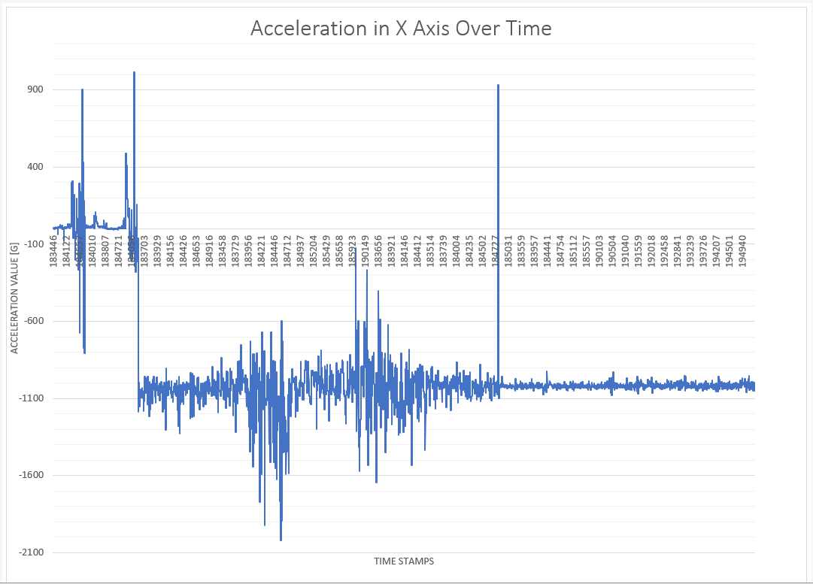

Figure 2 X Acceleration Data from file LSM183445

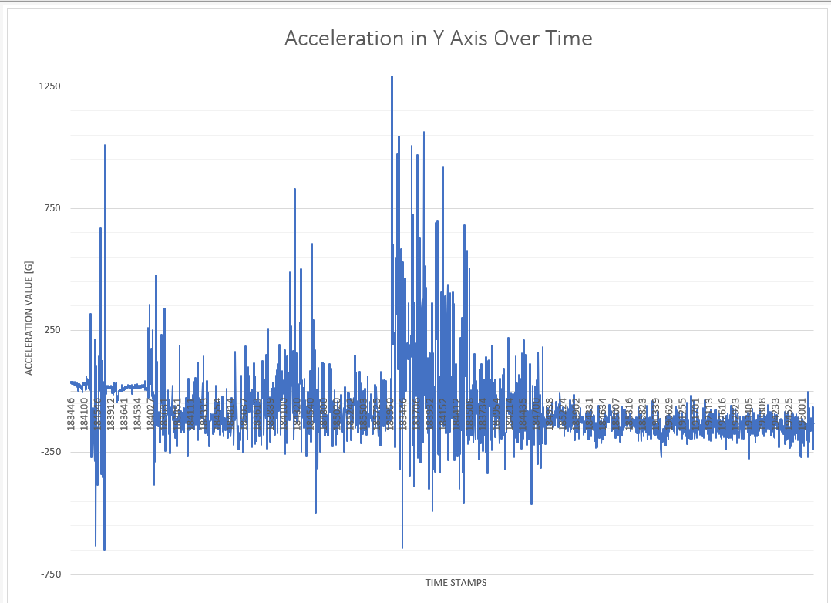

Figure 3 Y Acceleration Data from file LSM183445

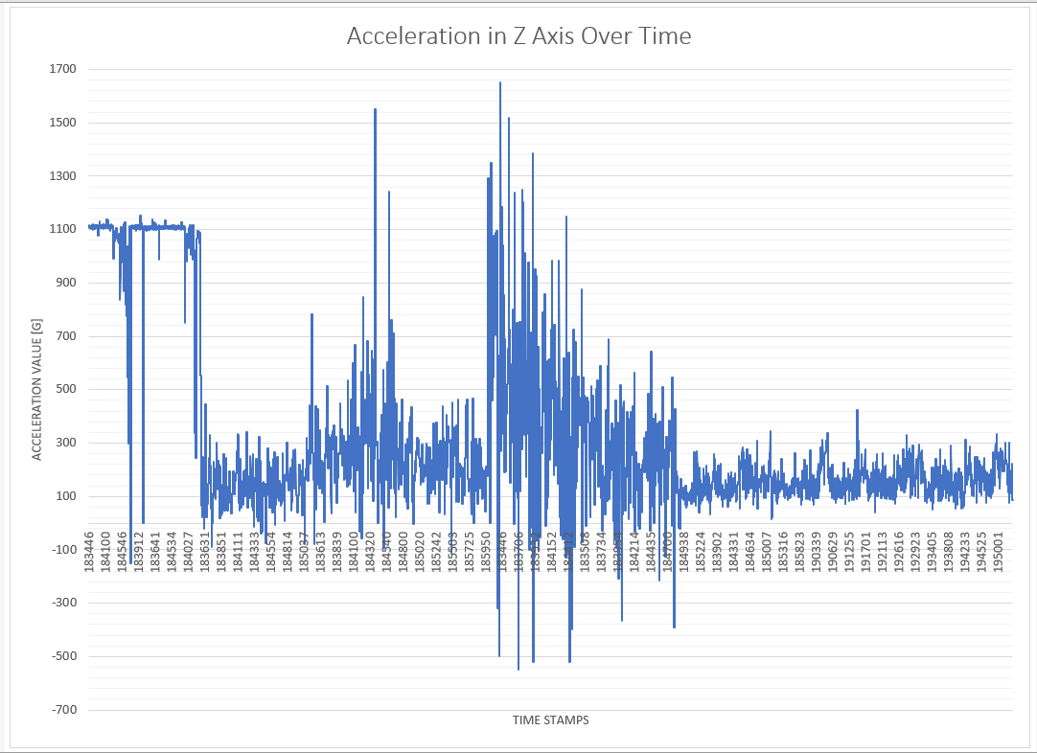

Figure 4 Z Acceleration Data from file LSM183445

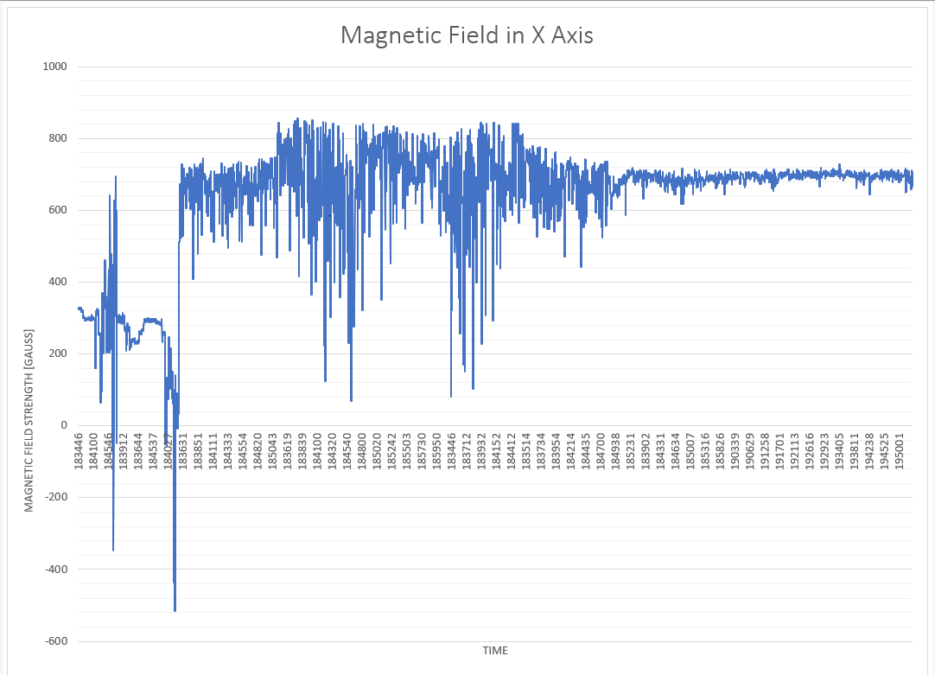

Figure 5 X Magnetic Field Data from file LSM183445

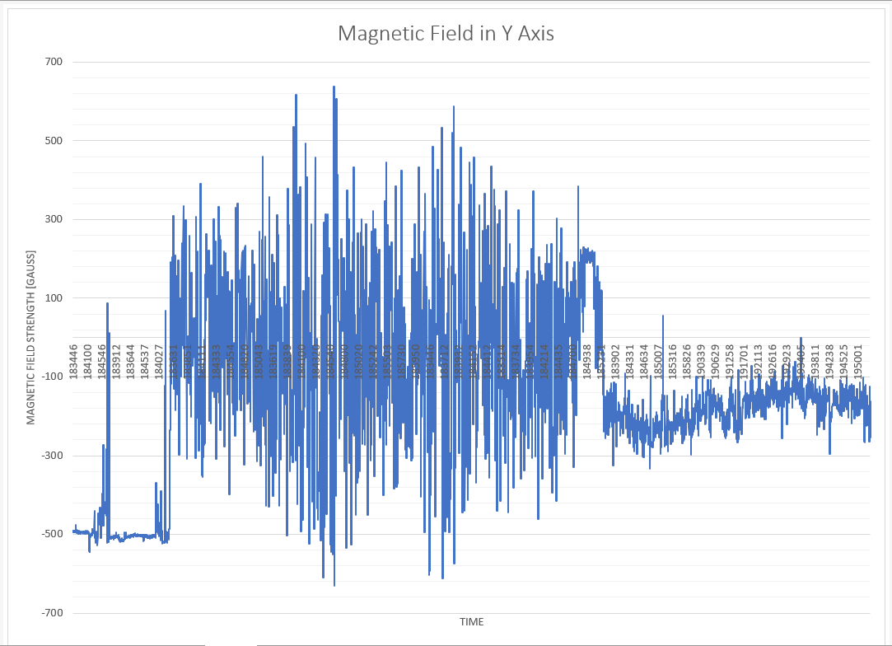

Figure 6 Y Magnetic Field Data from file LSM183445

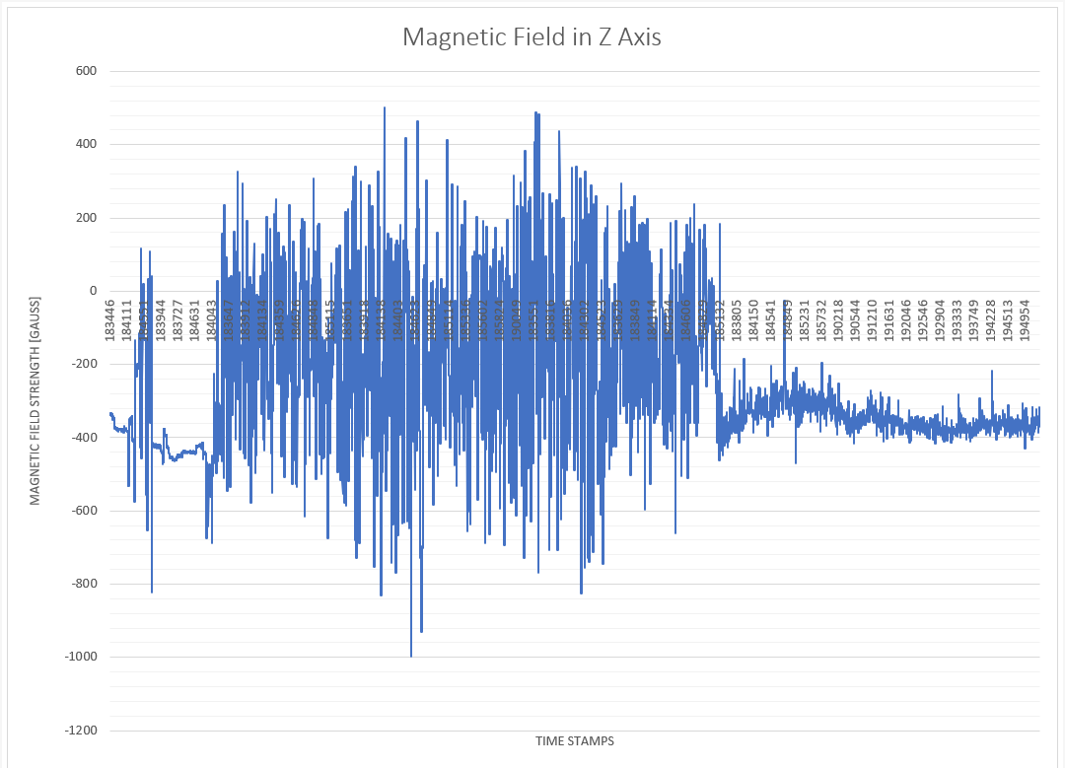

Figure 7 Z Magnetic Field Data from file LSM183445

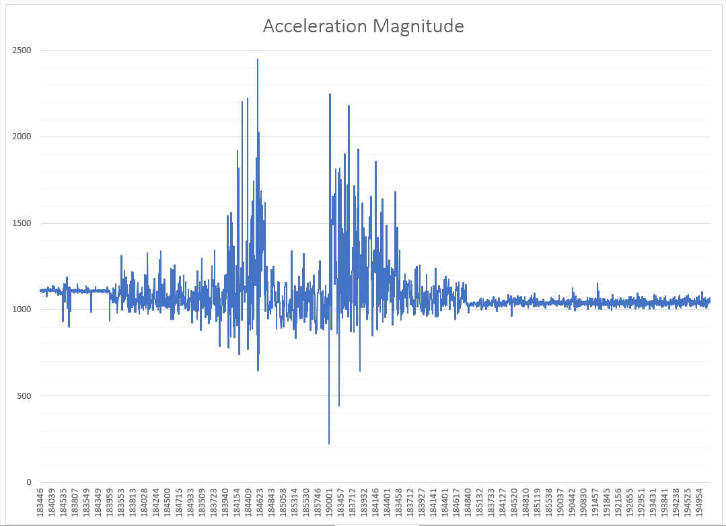

Figure 8 Magnitude of Acceleration data from file LSM183445

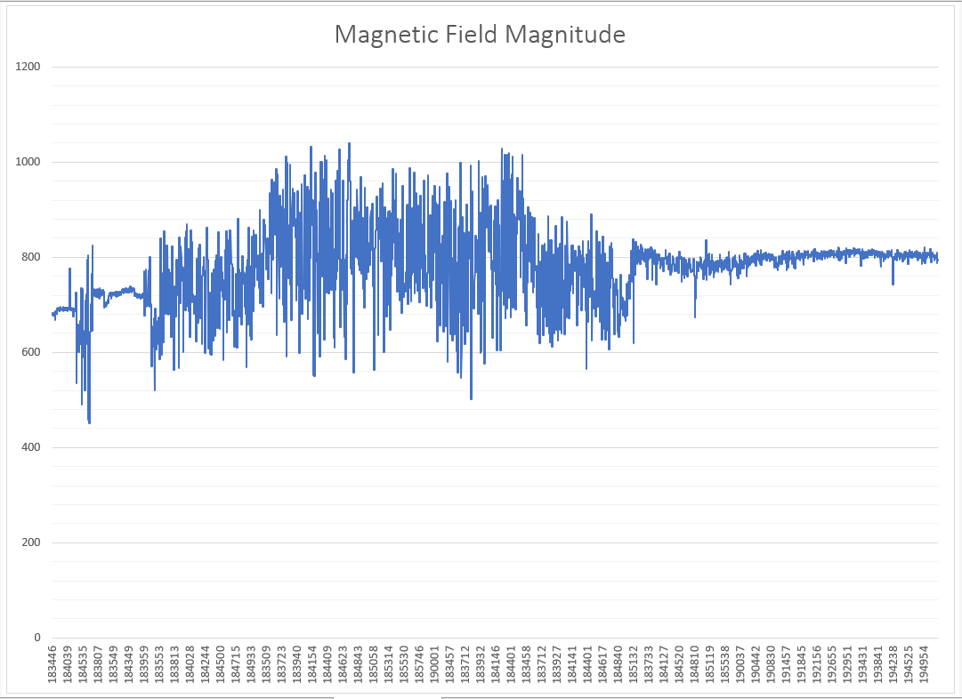

Figure 9 Magnitude of Magnetic Flux data from file LSM183445

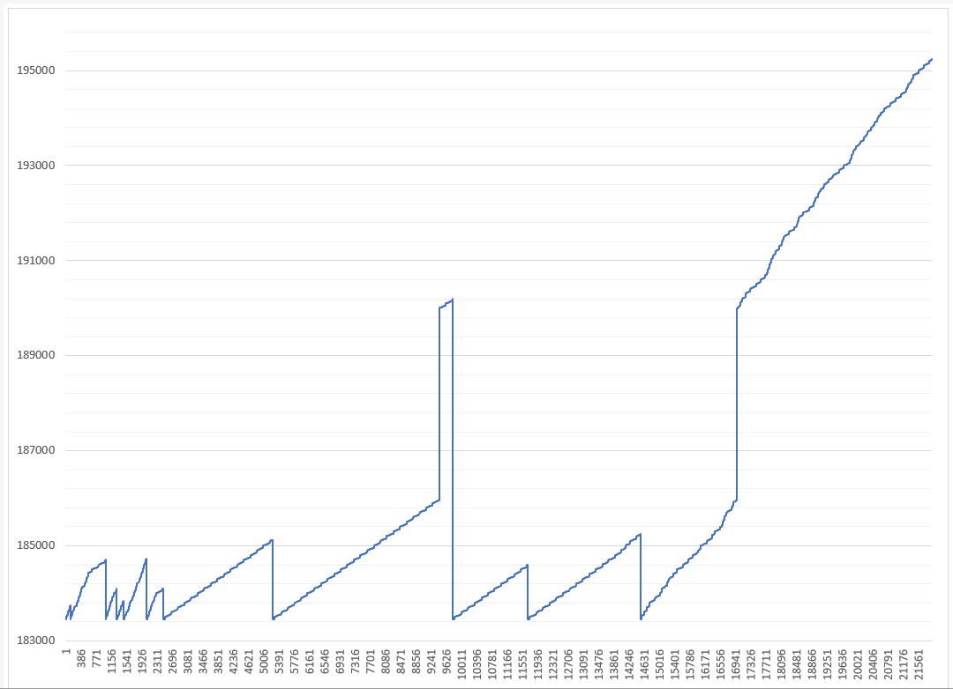

Figure 10 Time Stamps over Time